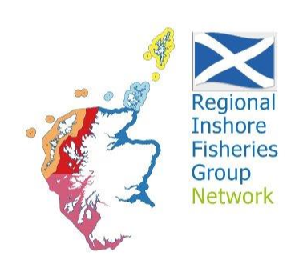

**Agenda for Shetland Regional Inshore Fisheries Group Meeting to be held at UHI Scalloway Room F8, and remotely on Teams on 31/10/2024 at 12.00-2.00pm (link to follow)**

*Adam Nutt (Technical Manager) and Daniella Dickson (Business Manager) from the Maritime and Coastguard Agency will be attending remotely and available to answer questions*

1. Welcome, apologies, minutes and actions from the previous meeting
2. Update on Shetland Juvenile Fish Study
3. Update on VR and Education projects
4. Marine Directorate Policy
5. Update from the SSMO
6. Update from the SFA
7. Update from Compliance
8. Issues from Shetland Fishermen
9. Visits and reports
10. AOCB
11. Date of next meeting